FUNCTIONAL SPECIFICATION

Document Name |  |  |  |  |  |  |  |  |  |  |  |  |  |  |  |  | Document Number
Analog Devices A2B Data Link and Physical Layer Specification |  |  |  |  |  |  |  |  |  |  |  |  |  |  |  |  | 000603.501.AD
DATE |  |  |  |  | REVISIONS |  |  |  |  |  |  |  |  |  |  |  |  | DR |  | CK | REFERENCE
10/20/2014 |  |  |  |  | First Release - Jim Lawlis |  |  |  |  |  |  |  |  |  |  |  |  |  |  |  | Jim Lawlis
11/21/2014 |  |  |  |  | AB Release –Jim Lawlis |  |  |  |  |  |  |  |  |  |  |  |  |  |  |  | MODIFIED BY
2/20/2015 |  |  |  |  | AC Release – Jim Lawlis |  |  |  |  |  |  |  |  |  |  |  |  |  |  |  | Jim Lawlis
9/29/2015 |  |  |  |  | AD Release – Jim Lawlis |  |  |  |  |  |  |  |  |  |  |  |  |  |  |  | APPROVED BY
 |  |  |  |  |  |  |  |  |  |  |  |  | (Previous editions may NOT be used)

I. Scope
This document is a technical regulation for a multiplex network between ECU’s, an inter-systems network. In combination with a protocol standard for multiplex it is a full specification regarding communication, but all demands in the Technical Regulation for the specific ECU also has to be fulfilled. In the figure below a relation between the different documents is described based on the OSI-model below.
OSI-model
ProtocolStandard
This document
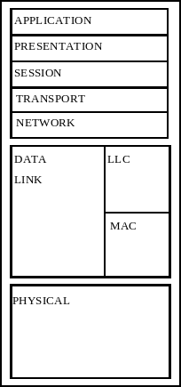




= Fully specified in this document (with reference to other documents)

= Partly specified in this document
= Not specified in this document

Ref [1] Figure document relations to OSI-model

This document shall be used to define and develop all production intent ECU’s for Ford Enterprise. The spec addresses only the lower two layers of the ISO network reference model (see Ref[1])

Attention: Failure to comply with these requirements of this specification by any production intent ECU may result in an inability to communicate on the vehicle network for which the ECU was intended.

II. Table Of Contents
I. Scope 2
II. Table Of Contents 3
III. References 4
1 Definitions / Abbreviations 4
1.1 General definitions 4
1.2 Abbreviations used in this document 5
2 PRODUCT OVERVIEW 5
3 REQUIREMENTS 5
3.1 Type of Network 5
3.2 Network transmission speed – 50 Mbps 5
3.3 System Level 6
3.3.1 Topology 6
3.3.2 Max length / Stub length and node distance 6
3.3.3 Number of Nodes 6
3.3.4 DC Line Bias 6
3.4 Connectors/Cables 6
3.5 ECU Level 7
3.5.1 General 7
3.5.2 Circuit Board Requirements 7
3.5.3 Master/Slave Termination 7
3.5.4 Power Supply/Reset 7
3.5.5 Wake/Sleep 7
3.5.6 Chokes 8
3.5.7 Ferrites 8
3.5.8 PFET 8
3.6 EMC Test Set-Up 8
3.7 Interface implementation, physical layer circuit and layout requirements: 9
3.7.1 Physical Layer Circuit Master 9
3.7.2 Physical Layer Circuit Slave 10
3.7.3 HSAutoLink 2nd Gen Layout Design Master/Slave 12
3.7.4 DLPL_ANALOG DEVICES A2B_7_004 – 2nd Gen HSAutolink Master/Slave Pin-out 12
3.7.5 HSAutoLink 1st Gen Design Master 13
3.7.6 DLPL_ANALOG DEVICES A2B_7_006 – 1st Gen HSAutolink Master Pin-out 13
3.7.7 HSAutoLink 1st Gen Layout Design Slave 14
3.7.8 DLPL_ANALOG DEVICES A2B_7_008 – 1st Gen HSAutolink Slave Pin-out 14
3.7.9 Layout Design Requirements 16
4 VERIFICATION METHODS 17
4.1 Verification traceability 18
Appendix A (Approved Components) 21
A.1 Approved PHYs 21
A.2 Physical Layer Critical Components 21
A.3 Approved Connector/Cable Components 21
A.4 Change Log 22

III. References

- The requirements of the documents listed in the following table, form a part of this specification. The revision levels shown in the table were the latest at the time this Functional Specification was written. In the event of a conflict between the requirements of this specification and these documents, the requirements of the documents in the table shall have precedence.

Rev Level | Requirement Document Name (ie, SDS/ARL requirements, Deviations, Engineering Specifications)
 | [1] - ISO 7498-1 Open Systems Interconnection - basic reference model
PRI | [2] - AD2410 Datasheet
 | [3] - AD24xx Board design & layout considerations
CS | [5] - EMC-CS-2009 Electronic component EMC Requirements, FMC
V1 | [6] Analog Devices A2B Link Implementation Specification
V1 | [7] Analog Devices A2B Hardware Review 000603.512

1 Definitions / Abbreviations

1.1 General definitions
A2B Pin – BP | One of the two pins connecting a network node with ANALOG DEVICES A2B interface towards the last slave.
A2B Pin - BN | One of the two pins connecting a network node with ANALOG DEVICES A2B interface towards the last slave.
A2B Pin – AP | One of the two pins connecting a network node with ANALOG DEVICES A2B interface towards the master.
A2B Pin - AN | One of the two pins connecting a network node with ANALOG DEVICES A2B interface towards the master.
multiplex: | To interleave or simultaneously transmit two or more messages on a single channel.
network: | A set of electronic and cabling devices facilitating the multidirectional exchange of information encoded in serial form. Each electronic device (in this case: ECU) is equipped with a specific, standardized electronic interface in order to guarantee compatibility between exchanged binary items of information.

1.2 Abbreviations used in this document
DPR | Design Prerequisites
ECU | Electronic Control Unit
EMC | Electromagnetic Compatibility
ESR | Equivalent Series Resistance
FMC | Ford Motor Company
ISO | International Standards Organisation
OSI | Open Systems Interconnect
PCB | Printed Circuit Board
PLL | Phase Locked Loop
SAE | Society of Automotive Engineers

2 PRODUCT OVERVIEW

The specification addresses only the lower two layers of the ISO network reference model (see Ref[1]).

3 REQUIREMENTS

Data Link Layer

3.1 Type of Network
DLPL_ANALOG DEVICES A2B_01_001
ANALOG DEVICES A2B in accordance with ref [2].
DLPL_ANALOG DEVICES A2B_01_002
In case of discrepancy between the standard documents and this specification, this specification has precedence.

General network requirements

Speed tolerance definition
DLPL_ANALOG DEVICES A2B_01_003
The total network transmission speed tolerance shall include all causes. For crystals this shall include manufacturing tolerance, aging and temperature. For PLL's, the tolerance shall be determined as specified by the semiconductor manufacturer, and shall include the effects of manufacturing, ageing, temperature and transmission speed. The requirement is defined in Reference [2]. “Input Jitter RMS Cycle to cycle tolerance”

3.2 Network transmission speed – 50 Mbps
Network transmission speed and bit timing requirement

DLPL_ANALOG DEVICES A2B_02_001
The speed of the high speed link transmission shall be 49.152 Mbps.

Physical layer

3.3 System Level

3.3.1 Topology

DLPL_ANALOG DEVICES A2B_03_001
The multiplex network consists of one twisted pair wire cable running from one ECU to the next. See the detailed requirements below.

3.3.2 Max length / Stub length and node distance
DLPL_ANALOG DEVICES A2B_03_002
There shall be a maximum wiring length according to the table:

Speed of the network | Between ECU's | Max Number of interconnections
49.152 Mbps | 10 m | 2

3.3.3 Number of Nodes
DLPL_ANALOG DEVICES A2B_03_003
ANALOG DEVICES A2B is electrically a point to point network. Nodes are added to the network by connecting the master port of one node to the slave port of the next in line. The maximum number of ECU's on the A2B network is 9.

3.3.4 DC Line Bias
DLPL_ANALOG DEVICES A2B_03_004
The DC Line Bias provided on the A2B cable shall be 5 volts +/- 20%.
The DC Line Bias Regulator must be capable of driving at least a 50mA load and be able to provide for 150mA of inrush current at start-up.
Note: Phantom Powered Slave nodes will require significantly higher drive capability and may require a higher bias voltage..

3.4 Connectors/Cables
DLPL_ANALOG DEVICES A2B_04_001
The module to Bus and Bus to Bus connectors for the ANALOG DEVICES A2B bus shall be chosen from an approved list of suppliers, reference - Appendix A.3

DLPL_ANALOG DEVICES A2B_04_002
Unshielded Cable Characteristics
The use of unshielded twisted pair is not approved for use in this system
This is a placeholder for unshielded cable characteristics when approved
******Must Include all cable requirements******************

DLPL_ANALOG DEVICES A2B_04_003
Shielded Cable Characteristics
Shielded Twisted Pair cable that forms the ANALOG DEVICES A2B bus shall be chosen from an approved list of suppliers - reference Appendix A.3

3.5 ECU Level

3.5.1 General

DLPL_ANALOG DEVICES A2B_05_001
The interface shall be specified according to ANALOG DEVICES A2B standard, ref [2, 3].

3.5.2 Circuit Board Requirements
DLPL_ANALOG DEVICES A2B_5_002
The circuit Board must be at least a 4 layer board. It must include a power layer, ground layer and 2 signal layers.

DLPL_ANALOG DEVICES A2B_5_003
The impedance between the transceiver signal layer and the ground layer, specified by the board PCB supplier shall be 50 Ohm +/- 10%.

3.5.3 Master/Slave Termination
DLPL_ANALOG DEVICES A2B_5_004
The termination and filtering requirements will be as specified in reference [2].

3.5.4 Power Supply/Reset
DLPL_ANALOG DEVICES A2B_5_005
The ANALOG DEVICES A2B network shall be fully functional, as a minimum, over the operating range 6V to 16V. Outside this operating range, it is recommended that modules continue to communicate. However, it is not acceptable for modules to send corrupt messages/illegal symbols, or disrupt the transmissions of other modules.
Note: Unique module feature requirements may require a larger operating range

3.5.5 Wake/Sleep
DLPL_ANALOG DEVICES A2B_5_006
This network will not implement the functionality or circuitry for Wake/Sleep.
3.5.5 Approved Transceivers
DLPL_ANALOG DEVICES A2B_5_007
Components approved for use in ECU’s connected to ANALOG DEVICES A2B networks are listed in Appendix A.1

3.5.6 Chokes
DLPL_ANALOG DEVICES A2B_5_008
Signal line common mode EMC chokes shall be required in all nodes. The choke selected must meet the requirements listed in Appendix A.2.

3.5.7 Ferrites
DLPL_ANALOG DEVICES A2B_5_009
Ferrites for bus bias and bus termination shall be required in all nodes. The Ferrite selected must meet the requirements listed in Appendix A.2.

3.5.8 PFET
DLPL_ANALOG DEVICES A2B_5_010
PFET shall be required in master node. The PFET selected must meet the requirements listed in Appendix A.2.

3.6 EMC Test Set-Up

The suggested set-up for the ANALOG DEVICES A2B load box, for use during EMC testing, can be found on the NetCom eRoom:
(tbd)

3.7 Interface implementation, physical layer circuit and layout requirements:

DLPL_ANALOG DEVICES A2B_7_001 - Master
The following circuit diagram shall be implemented in order to maximize the EMC performance. Each ECU shall incorporate one, and only one, transceiver per network, unless agreed with the relevant FMC design authority for each vehicle program to which the ECU shall be fitted. It remains the responsibility of the ECU supplier to ensure that the ECU fully complies with the requirements of ref [8].

3.7.1 Physical Layer Circuit Master
Circuit drawing
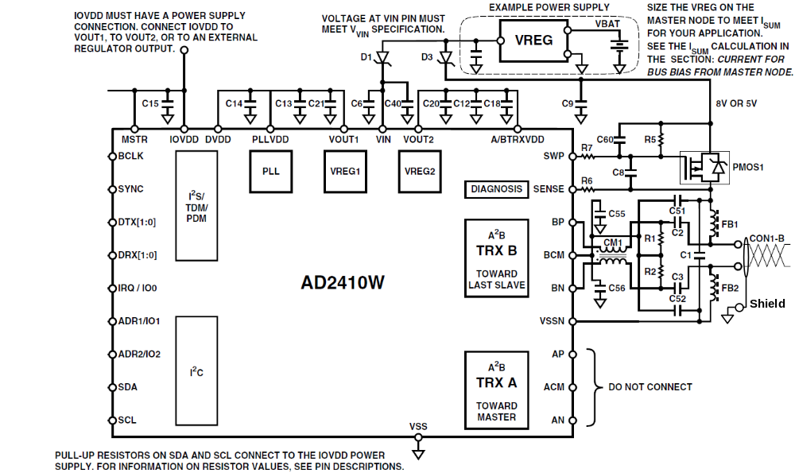

BOM Master

Item | Qty | Ref Des | Type | Value | Recommended Size for layout | Metric
1 | 4 | C1, C9,  C51, C52 | Capacitor | 33nF, ± 10%, ≥35V | 0402 | 1005
2 | 2 | C2-C3 | Capacitor | 10nF, ± 10%, ≥35V | 0402 | 1005
3 | 1 | C8 | Capacitor | 3.3nF, ± 10%, ≥35V | 0402 | 1005
4 | 6 | C12, C13, C14, C15,  C55, C56 | Capacitor | 0.1uF, ± 10%, ≥16V | 0402 | 1005
5 | 1 | C18 | Capacitor | 10nF, ± 10%, ≥16V | 0402 | 1005
6 | 2 | C20-C21 | Capacitor | 4.7uF, ± 10%, ≥35V | 0805 | 2012
7 | 1 | C6 | Capacitor | 0.1uF, ± 10%, ≥16V | 0402 | 1005
8 | 1 | C40 | Capacitor | 10uF, ± 10%, ≥35V | 1206 | 3216
9 | 1 | C60 | Capacitor | 15nF, ± 10%, ≥35V | 0402 | 1005
10 | 2 | R1-R2 | Resistor | 113Ohm, ±1%,≥1/4W | 0805/1206 | 2012/3216
11 | 1 | R5 | Resistor | 33k, ± 5%,≥1/10W | 0402 | 1005
12 | 1 | R6 | Resistor | 1.0k, ± 5%,≥1/10W | 0402 | 1005
13 | 1 | R7 | Resistor | 3.3k, ± 5%,≥1/10W | 0402 | 1005
14 | 3 | FB1-FB3 | Ferrite Bead | See Appendix A.2
15 | 1 | PMOS1 | PMOS-FET | See Appendix A.2
16 | 1 | D1 | Diode | ≥100mA, 30V | 0603 | 1608
17 | 1 | D3 | Diode | ≥400mA, 30V | SOD-323
18 | 1 | CM1 | CM Choke | See Appendix A.2
19 | 1 | AD2410 | Transceiver | AD2410WCCSZ | 32-LFCSP 5x5

3.7.2 Physical Layer Circuit Slave
DLPL_ANALOG DEVICES A2B_7_002 - Slave

Circuit drawing
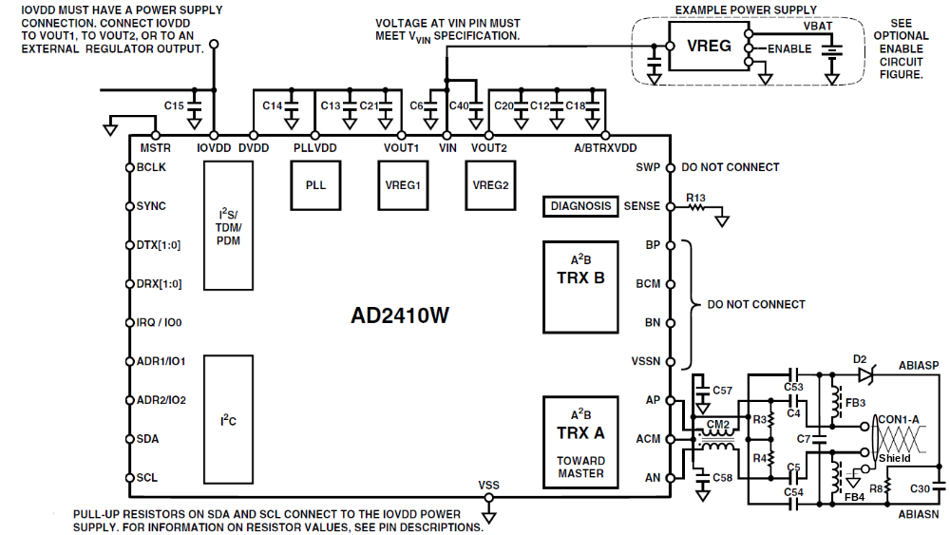

BOM Slave

Item | Qty | Ref Des | Type | Value | Recommended Size for layout | Metric
1 | 2 | C53, C54 | Capacitor | 33nF, ±10%, ≥35V | 0402 | 1005
2 | 3 | C4, C5, C18 | Capacitor | 10nF, ±10%, ≥35V | 0402 | 1005
3 | 1 | C7 | Capacitor | 0.47uF, ±10%, ≥35V | 0603 | 1608
4 | 6 | C12-C15  C57-C58 | Capacitor | 0.1uF, ±10%, ≥16V | 0402 | 1005
5 | 2 | C20-C21 | Capacitor | 4.7uF, ±10%, ≥35V | 0805 | 2012
6 | 1 | C30 | Capacitor | 4.7uF, ±10%, ≥35V | 1206 | 3216
7 | 1 | C6 | Capacitor | 0.1uF, ±10%, ≥16V | 0402 | 1005
8 | 1 | C40 | Capacitor | 10uF, ±10%, ≥35V | 1206 | 3216
9 | 2 | R3-R4 | Resistor | 113Ohm,±1%,≥1/4W | 0805/1206 | 2012/3216
10 | 1 | R8 | Resistor | 3.3k,±5%,≥1/4W | 0805 | 2012
11 | 1 | R13 | Resistor | 33k, ±5%≥1/10W | 0402 | 1005
12 | 2 | FB3-FB4 | Ferrite Bead | See Appendix A.2
13 | 1 | D2 | Diode | ≥ 100mA, 30V | 0603 | 1608
14 | 1 | CM2 | CM Choke | See Appendix A.2
15 | 1 | AD2410 | Transceiver | AD2410WCCSZ | 32-LFCSP 5x5

3.7.3 HSAutoLink 2nd Gen Layout Design Master/Slave
DLPL_ANALOG DEVICES A2B_7_003 – 2nd Gen Master/Slave
The following screen shots illustrate layout recommendations for the A2B circuit based on an example of a size constrained A2B module with 2nd Generation HSAutoLink connector. This A2B module example has been developed as a 6 layer board to meet size and function requirements. 4 board layers are sufficient for A2B, the 2 extra layers are hardly used for the module and not required in a less constrained implementation.
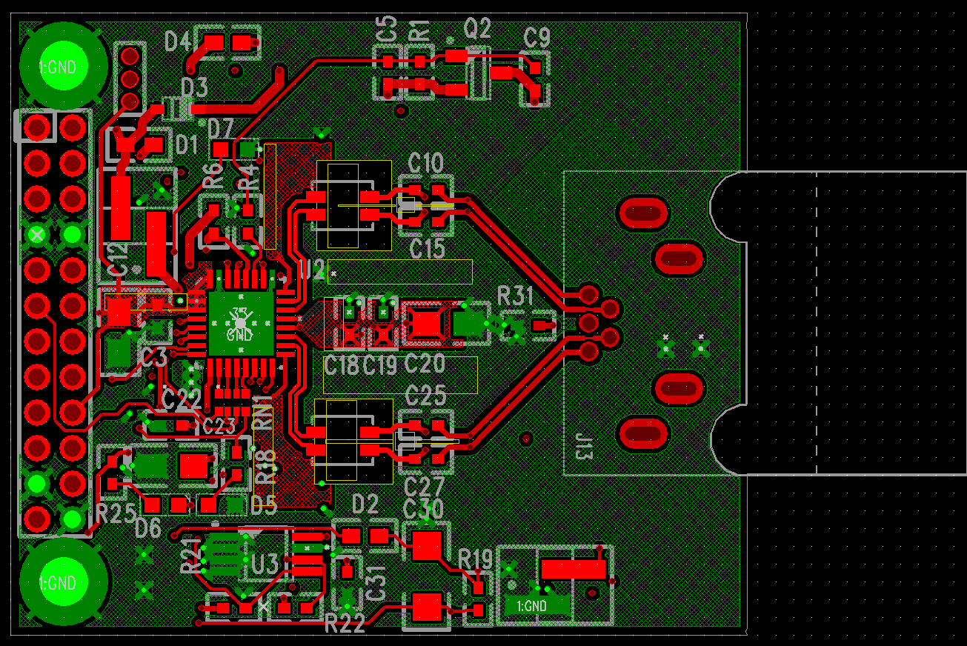

A2B HSAL Gen 2 module - TOP layer

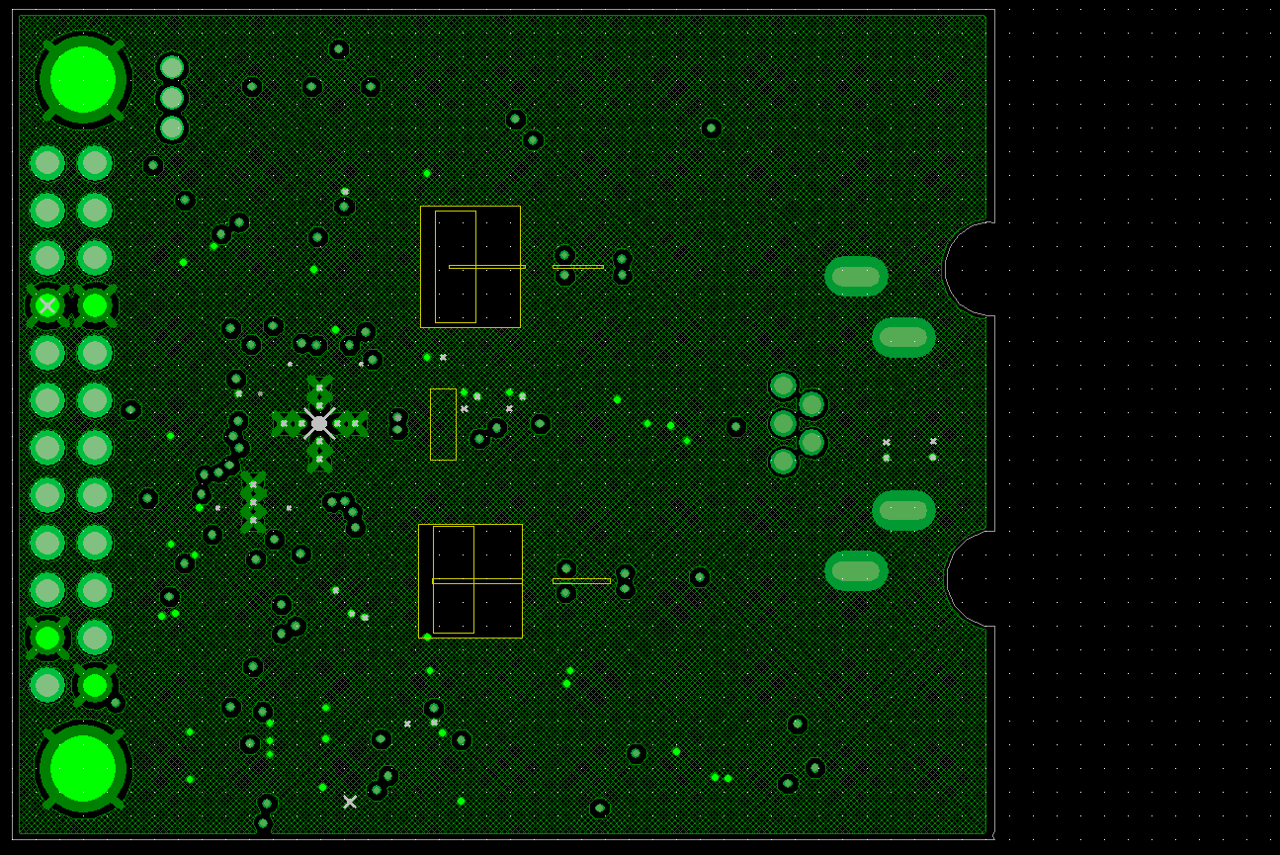

A2B HSAL Gen 2 module - GND layer

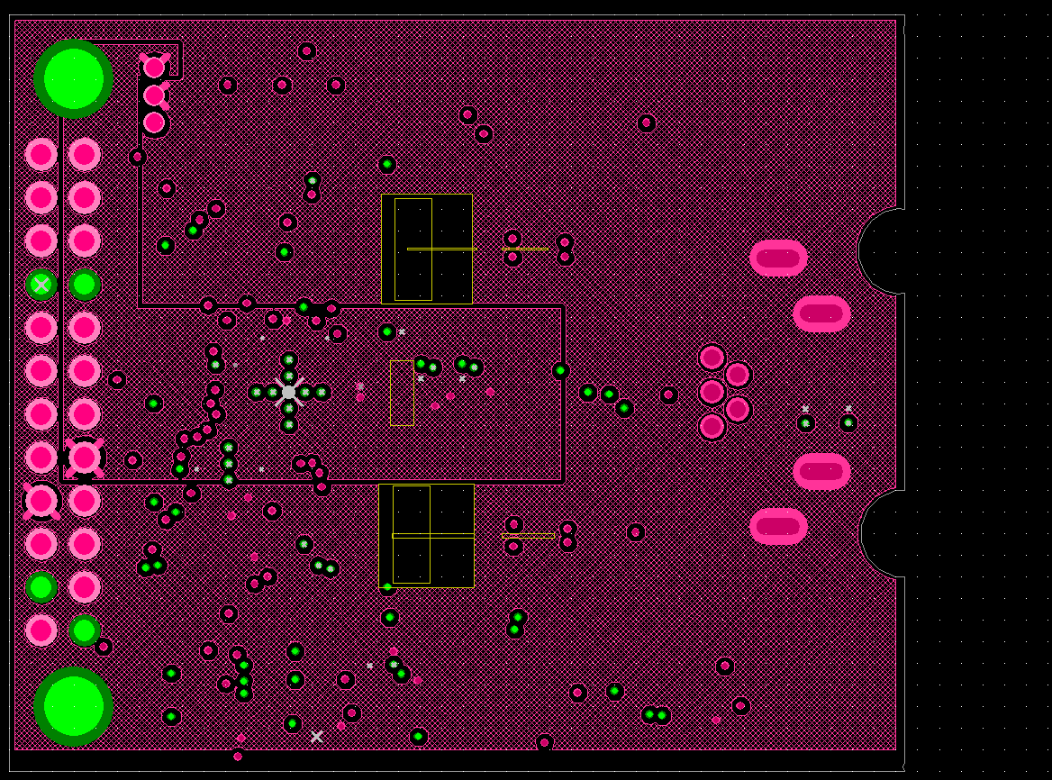

A2B HSAL Gen 2 module - Power layer

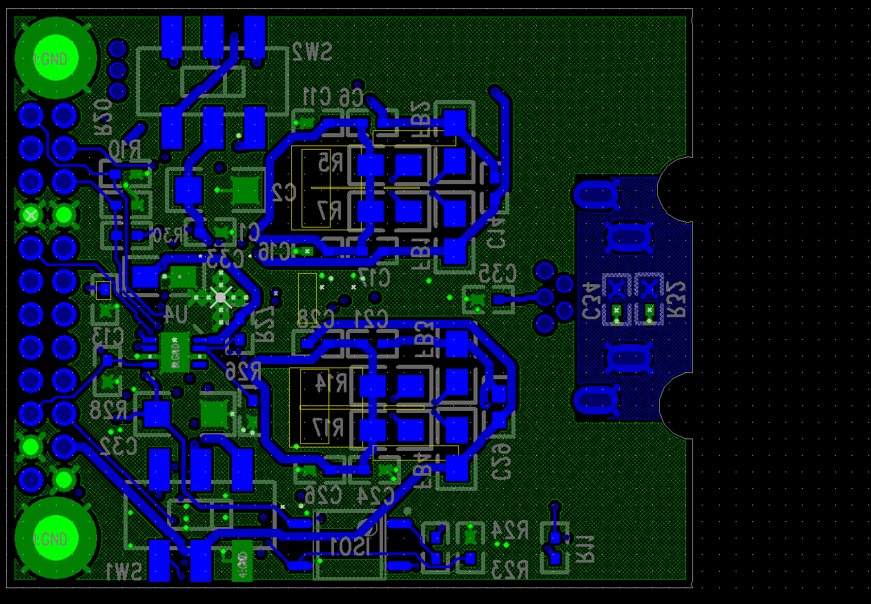

A2B HSAL Gen 2 module - Bottom layer

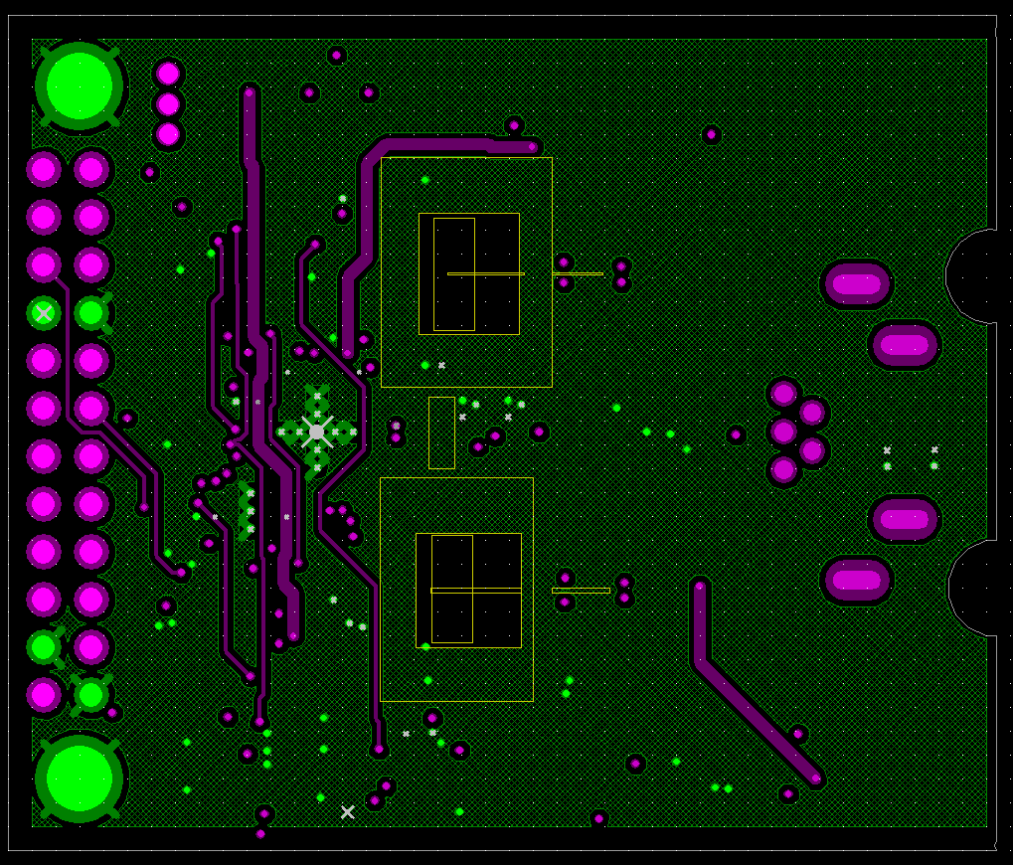

A2B module HSL Gen 2 inner layer

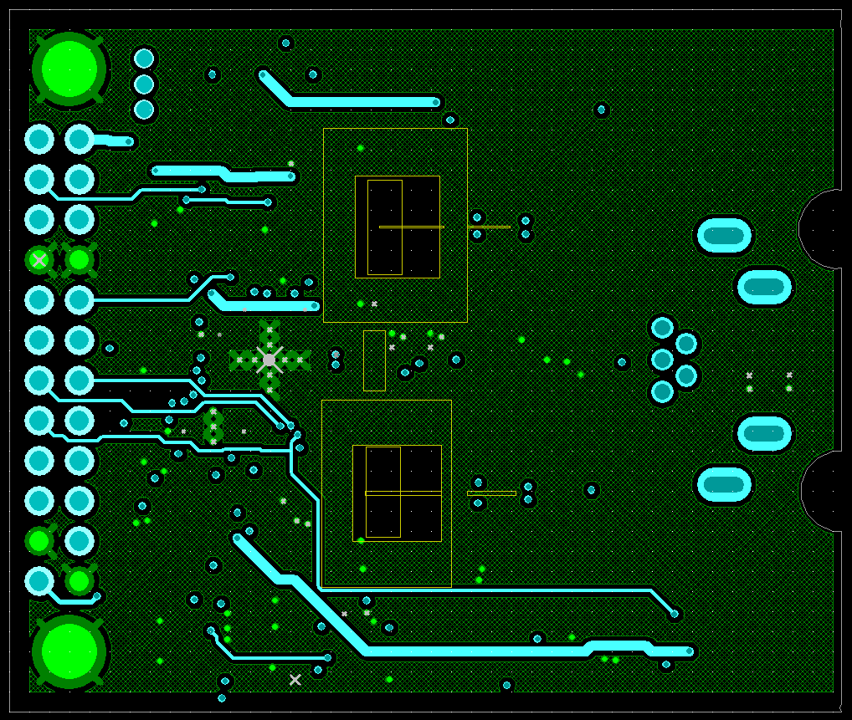

A2B Module HSAL Gen 2 - Inner layer
Figure 1 - A2B module HSL Gen 2 inner layer

3.7.4 DLPL_ANALOG DEVICES A2B_7_004 – 2nd Gen HSAutolink Master/Slave Pin-out

Molex HSAutoLink 2nd Gen
Pin Number | Description
1 | AN – A2B port A negative
2 | AP – A2B port A positive
3 | No Connect (GND on PCB)
4 | BP – A2B port B positive
5 | BN – A2B port B negative

3.7.5 HSAutoLink 1st Gen Design Master
DLPL_ANALOG DEVICES A2B_7_005 – 1st Gen Master
Top and Bottom Layer: Top Layer:
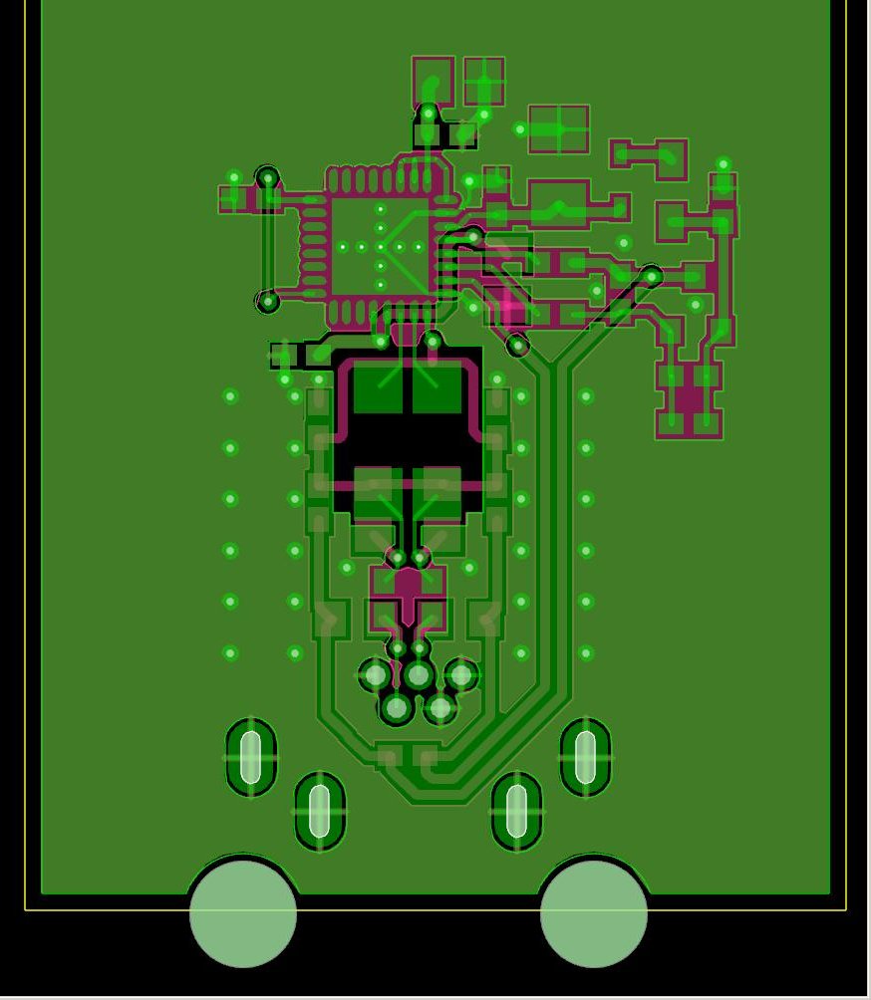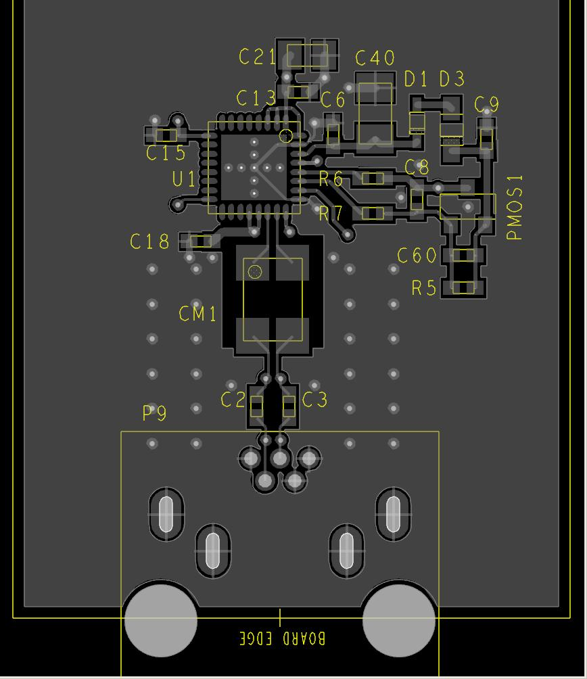
Bottom Layer: Ground Layer:
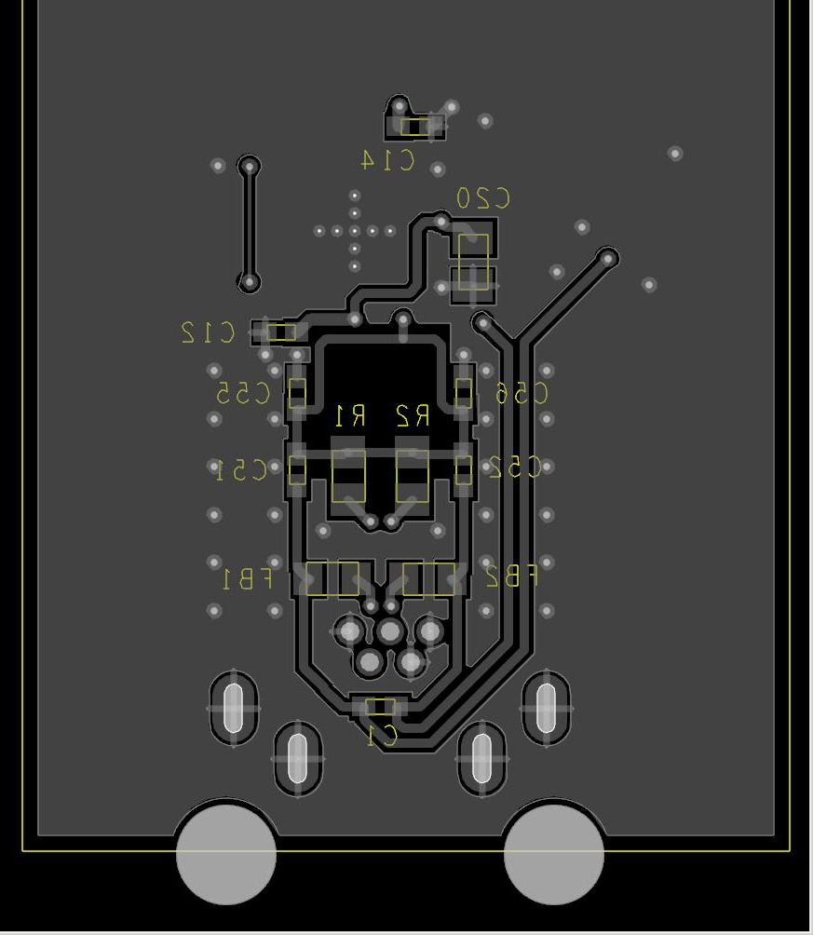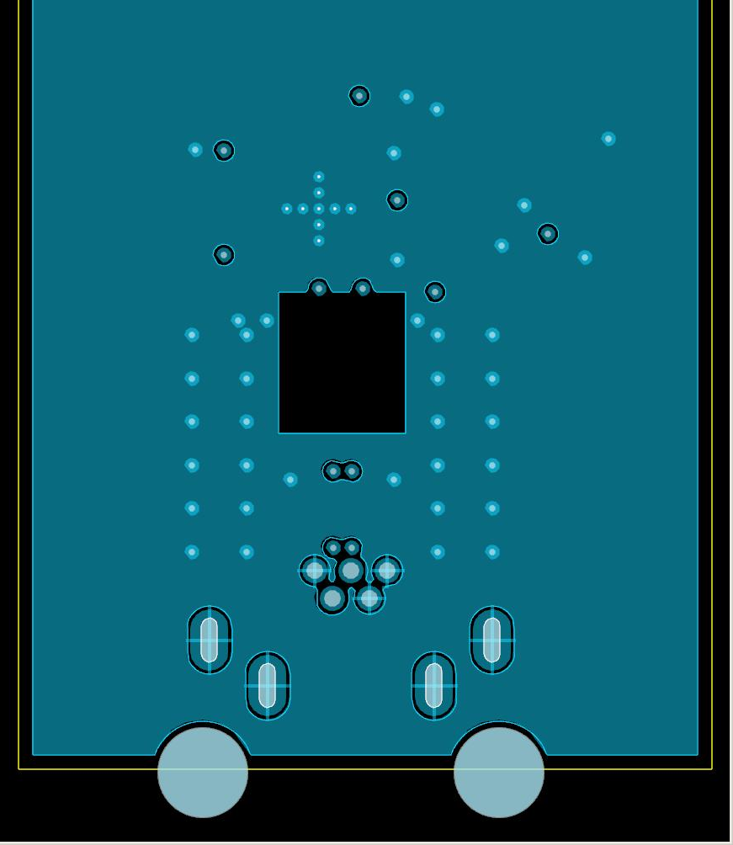

3.7.6 DLPL_ANALOG DEVICES A2B_7_006 – 1st Gen HSAutolink Master Pin-out

Molex HSAutoLink 1st Gen
Pin Number | Description
1 | No Connect (GND on PCB)
2 | BP – A2B port B positive
3 | BN – A2B port B negative
4 | Drain (GND on PCB)
5 | No Connect (GND on PCB)

3.7.7 HSAutoLink 1st Gen Layout Design Slave
DLPL_ANALOG DEVICES A2B_7_007 – 1st Gen Slave
Top and Bottom Layer: Top Layer:
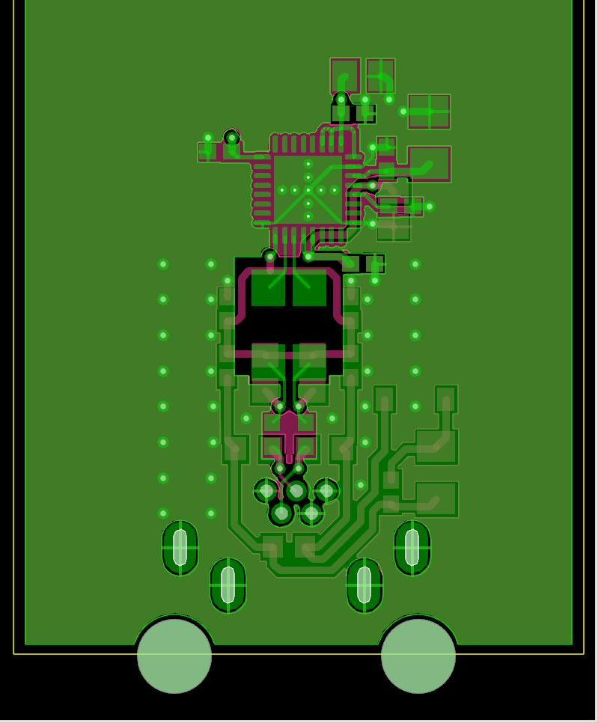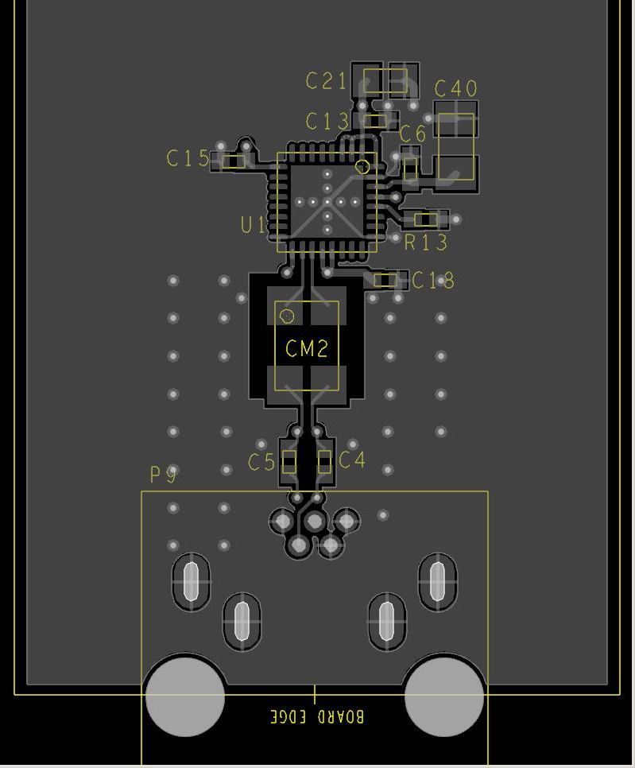
Bottom Layer: Ground Layer:
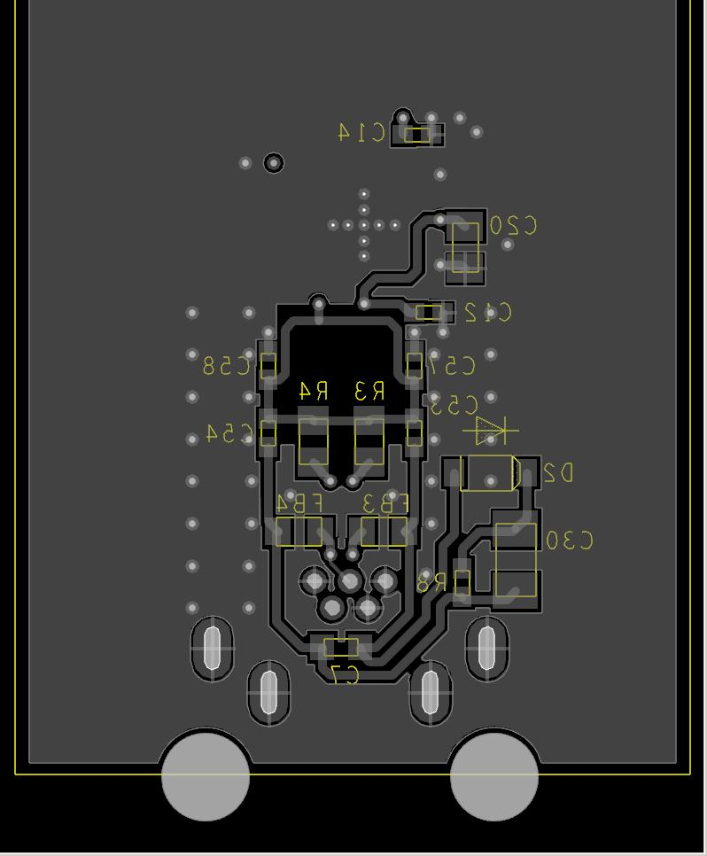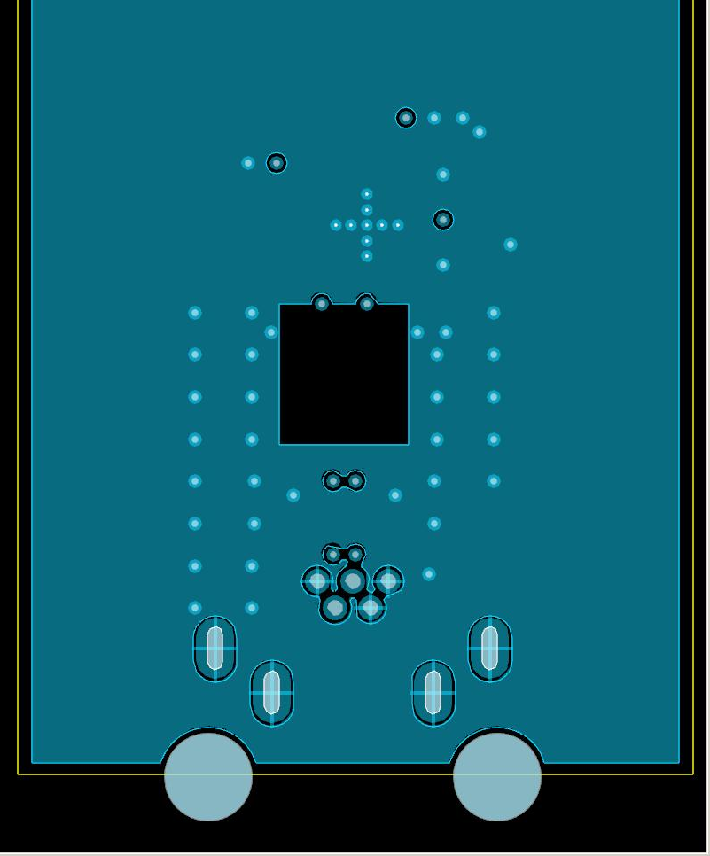

3.7.8 DLPL_ANALOG DEVICES A2B_7_008 – 1st Gen HSAutolink Slave Pin-out

Molex HSAutoLink 1st Gen
Pin Number | Description
1 | No Connect (GND on PCB)
2 | AP – A2B port A positive
3 | AN – A2B port A negative
4 | Drain (GND on PCB)
5 | No Connect (GND on PCB)

3.7.9 Layout Design Requirements

Refer to reference [3] for additional detailed layout recommendations.

General
DLPL_ANALOG DEVICES A2B_7_009
All grounding of the ANALOG DEVICES A2B transceiver and capacitors shall be made to ECU signal ground.

DLPL_ANALOG DEVICES A2B_7_010
All capacitors shall be ceramic or equivalent.

DLPL_ANALOG DEVICES A2B_7_011
All guard tracks shall be at least 0.5 mm wide and grounded at least every 10 mm.
Ground Planes should be stitched at least every 10 mm.

DLPL_ ANALOG DEVICES A2B _7_012
All magnetic components (ferrites, chokes) shall be located at least 2 mm from each other.

DLPL_ ANALOG DEVICES A2B _7_013
All unused pins and the mechanical shield tabs shall all be connected to Ground

Transceiver
DLPL_ANALOG DEVICES A2B_7_014
A connected ground plane is required under the transceiver chip on the component layer of the PCB.
Picture below shows transceiver foot print, recommended solder mask, paste mask and stitching of the ground plane.
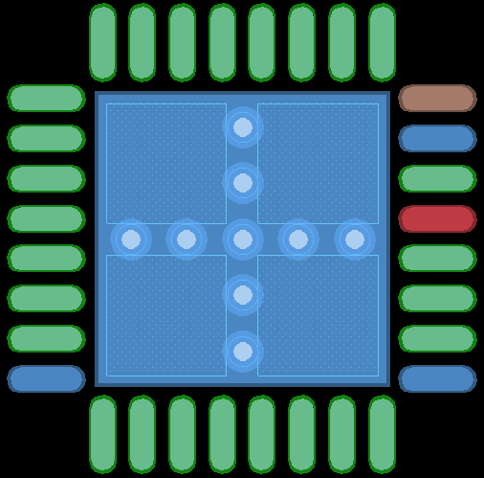
DLPL_ANALOG DEVICES A2B_7_015
Transceiver shall be located as close to edge connector as possible. Other IC’s are not permitted between edge connector and the transceiver.

DLPL_ANALOG DEVICES A2B_7_016
The decoupling capacitors shall be placed as close as possible to the transceiver. When multiple decoupling capacitors are specified, the smallest capacitor value shall be located closest to the pin.

Communication Circuits
DLPL_ANALOG DEVICES A2B_7_017
The Impedance, measured from 20 MHz to 100 MHz, between circuits AP & AN and BP & BN shall be 100 Ohms +/- 10%. The Impedance of those traces towards the ground layer should be 50 Ohm +/-10%.

DLPL_ANALOG DEVICES A2B_7_018

ANALOG DEVICES A2B AN & AP and BN & BP circuits between edge connector and transceiver shall be as short as possible and routed side-by-side. Guard tracks are required for the outside of all differential traces from the transceiver to the Common mode choke. See Below:
- AN and BN should be guarded by ACM and BCM or grounded guard tracks.
- AP and BP should be guarded by TRXVDD, Common Mode (CM) or grounded guard tracks.

DLPL_ANALOG DEVICES A2B_7_019
The length of the ANALOG DEVICES AN & AP and BN & BP circuits from the transceiver to the Physical Layer shall not differ more than 3 mm.
Note: differences in connector pin lengths must be accounted for in the circuit board traces.

DLPL_ ANALOG DEVICES A2B _7_20
A keep out area on all layers is required underneath the common mode choke.
- The keep out must extend at least 3 mm to the outside of the choke.
- See reference document [3] section PCB layout – EVAL-AD2410WCZ - 4 layers

DLPL_ ANALOG DEVICES A2B _7_021
ANALOG DEVICES A2B AN & AP and BN & BP circuits must be routed symmetrically directly from the transceiver to the connector without any stubs (example: no test points).

4 VERIFICATION METHODS
Node conformance test
The node must demonstrate conformance to the applicable tests defined in the conformance tests in table below.

Protocol | Conformance test
Ford Hardware Review DV | Ref [7]

4.1 Verification traceability
The following matrix itemizes all requirements specified herein and cross-references them to one of several means for verification. Due the criticality of a requirement there may be more than one procedure identified for verification. Below is a brief description of each of the verification methods:

ECU Level T.P.'s DV test where requirement is verified.
Vehicle Level T.P.'s DV test where requirement is verified.
Hardware Review Inspection Inspection where requirement is verified reference [5], [6].
Application Testing Testing performed by (sub)system engineering verifies the requirement.

Table 1: Trace-ability Matrix
Requirement No. | System Level DV | NetComm HW Inspection
DLPL_ANALOG DEVICES A2B_01_001 | X
DLPL_ANALOG DEVICES A2B_01_002 | X
DLPL_ANALOG DEVICES A2B_01_003 |  | X
DLPL_ANALOG DEVICES A2B_02_001 | X | X
DLPL_ANALOG DEVICES A2B_03_001 | X
DLPL_ANALOG DEVICES A2B_03_002 | X | X
DLPL_ANALOG DEVICES A2B_03_003 |  | X
DLPL_ANALOG DEVICES A2B_03_004 |  | X
DLPL_ANALOG DEVICES A2B_04_001 |  | X
DLPL_ANALOG DEVICES A2B_04_002
DLPL_ANALOG DEVICES A2B_04_003 |  | X
DLPL_ANALOG DEVICES A2B_05_001 |  | X
DLPL_ANALOG DEVICES A2B_05_002 |  | X
DLPL_ANALOG DEVICES A2B_05_003 | X | X
DLPL_ANALOG DEVICES A2B_05_004 |  | X
DLPL_ANALOG DEVICES A2B_05_005 | X
DLPL_ANALOG DEVICES A2B_05_006 | X | X
DLPL_ANALOG DEVICES A2B_05_007 |  | X
DLPL_ANALOG DEVICES A2B_05_008 |  | X
DLPL_ANALOG DEVICES A2B_05_009 |  | X
DLPL_ANALOG DEVICES A2B_05_010 |  | X
DLPL_ANALOG DEVICES A2B_07_001 |  | X
DLPL_ANALOG DEVICES A2B_07_002 |  | X
DLPL_ANALOG DEVICES A2B_07_003 |  | X
DLPL_ANALOG DEVICES A2B_7_004 |  | X
DLPL_ANALOG DEVICES A2B_7_005 |  | X
DLPL_ANALOG DEVICES A2B_7_006 |  | X
DLPL_ANALOG DEVICES A2B_7_007 |  | X
DLPL_ANALOG DEVICES A2B_7_008 |  | X
DLPL_ANALOG DEVICES A2B_7_009 |  | X
DLPL_ANALOG DEVICES A2B_7_010 |  | X
DLPL_ANALOG DEVICES A2B_7_011 |  | X
DLPL_ANALOG DEVICES A2B_7_012 |  | X
DLPL_ANALOG DEVICES A2B_7_013 |  | X
DLPL_ANALOG DEVICES A2B_7_014 |  | X
DLPL_ANALOG DEVICES A2B_7_015 |  | X
DLPL_ANALOG DEVICES A2B_7_016 |  | X
DLPL_ANALOG DEVICES A2B_7_017 |  | X
DLPL_ANALOG DEVICES A2B_7_018 |  | X
DLPL_ANALOG DEVICES A2B_7_019 |  | X
DLPL_ANALOG DEVICES A2B_7_020 |  | X
DLPL_ANALOG DEVICES A2B_7_021 |  | X

Appendix A (Approved Components)

A.1 Approved PHYs

Ref Des | Type | Value | Size | Supplier | Part Number
AD2410 | Transceiver | AD2410WCCSZ | 32-LFCSP | Analog Devices | AD2410WACSZ

A.2 Physical Layer Critical Components

Chokes

Ref Des | Type | Value | Size | Supplier | Part Number
CM1-CM2 | CM Choke | 51uH | ACT1210 | TDK | ACT1210-510-2P
CM1-CM2 | CM Choke | 51uH | ACT45B | TDK | ACT45B-510-2P

Ferrites
Ref Des | Type | Value | Size | Metric | Supplier | Part Number
FB1-FB4 | Ferrite Bead | 1kOhm @100MHz | 0805 | 2012 | TDK | MPZ2012S102A

PFET
Ref Des | Type | Value | Size | Supplier | Part Number
PMOS1 | PMOS-FET | 30V, 2A, 130m Ohm | SOT-23 | Infineon | BSS308PE H6327TR-ND
PMOS1 | PMOS-FET | 30V, 2A, 130m Ohm | SOT-23 | Diodes Inc | DMP3098L-7

A.3 Approved Connector/Cable Components

Connectors/Cables
Supplier | Type | Family
Molex | HSAL1 RA Header (Thru-hole) | HSAL1 Header
Molex | HSAL1 Mini-B LVDS 1p Cable | HSAL1 LVDS 1p

A.4 Change Log
Changes
Specification Version | Requirement Number | Change
AB | DPL_ANALOG DEVICES A2B_7)001 Master | R5, R6, R7 – 10% changed to 5%
AB | DPL_ANALOG DEVICES A2B_7)001 Master | Transceiver full part number added:  AD2410W changed to AD2410WACSZ
AB | DPL_ANALOG DEVICES A2B_7)002 Slave | R8, R13 – 10% changed to 5%
AB | DPL_ANALOG DEVICES A2B_7)002 Slave | R8 – 1/10W, 0402 changed to 1/4W, 0805
AB | DPL_ANALOG DEVICES A2B_7)002 Slave | Transceiver full part number added:  AD2410W changed to AD2410WACSZ
AB | DLPL_ ANALOG DEVICES A2B _7_011 | Added clarification of what to do with unused pins and the mechanical tabs
AC | DLPL_ANALOG DEVICES A2B_7_001 - Master | Power Rating for 113 Ohm resistors changed from 1/8 W to ¼ W
AC | DLPL_ANALOG DEVICES A2B_7_002 - Slave | Power Rating for 113 Ohm resistors changed from 1/8 W to ¼ W
AD | DLPL_ANALOG DEVICES A2B_7_003-4 | Added 2nd Generation layout and pinout requirements
AD | DLPL_ANALOG DEVICES A2B_7_005-21 | Renumbered requirements
AD | DLPL_ANALOG DEVICES A2B_3_003 | Clarified number of nodes
AD | DLPL_ANALOG DEVICES A2B_3_004 | Added inrush current capability
AD | DLPL_ANALOG DEVICES A2B_7_001 | Updated transceiver part number
AD | DLPL_ANALOG DEVICES A2B_7_002 | Updated transceiver part number
AD | DLPL_ANALOG DEVICES A2B_7_003 | Clarified the layout introduction paragraph
AD | Appendix A - Approved Phys | Updated transceiver part number
AD | Appendix A - PFET | Added a new part to the approved list

